|  |  |  |
| --- | --- | --- |
| **LAB101 Assignment** | **Type:** | **Short Assignment** |
| **Code:** | **C.S.P0046** |
| **LOC:** | **70** |
| **Slot(s):** | **1** |

**Title**

Basic Computation Practice.

**Background**

N/A

**Program Specifications**

Implement a program with the following functions:

* Output the first primes of the inputted number.
* Check a Fibonacci number.
* Sum of digits of a positive natural number.

***Function details:***

1. Function 1: Display program instruction and prompt users to select an option from 1 to 3.

* Users run the program. The program displays instruction and asks users to select an option from 1 to 3:
  + 1 – output first primes of the inputted number
  + 2 – check a Fibonacci number
  + 3 – sum of digits in a positive natural number
* If user inputs 1, perform Function 2.
* If user inputs 2, perform Function 3.
* If user inputs 3, perform Function 4.

1. Function 2: Output first primes of the inputted number

* Prompt users to input a number (n) which is 0 < n <= 50. Users re-input if n is not in valid range.
* Output primes from 1 to n.
* Go back to Function 1.

1. Function 3: Check a Fibonacci number.

* Ask users to input a number (n) which is 0 < n <= 1000. Users re-input if n is not in valid range.
* Return 1 if the inputted number is a Fibonacci number. Otherwise, return 0
* Go back to Function 1.

1. Function 4: Sum of digits in a positive natural number.

* Ask users to input a positive natural number. Users re-input the number if it is not valid.
* Output sum of the digits in the inputted number.
* Go back to Function 1.

***Expectation of User interface:***

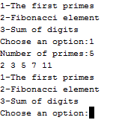

*Output first primes of the inputted number ’n’*

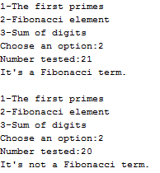

*Check a Fibonacci number.*

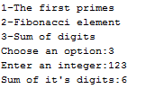

*Sum of digits in a natural number*

**Guidelines**

**Definition:**

The Fibonacci Sequence is the series of numbers: 0, 1, 1, 2, 3, 5, 8, 13, 21, 34, ... The next number is found by adding up the two numbers before it.

For example, 2 is found by adding the two numbers before it (1+1). Similarly, 3 is found by adding the two numbers before it (1+2)

Regression formula of Fibonacci sequence

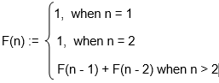

Example: 1, 1, 2, 3, 5, 8, 13, 21 … are first Fibonacci numbers.

A prim is a natural number divisible only by 1 and itself. 0 and 1 is not considered a prime number

Primes from 2 to 100:

2, 3, 5, 7, 11, 13, 17, 19, 23, 29, 31, 37, 41, 43, 47, 53, 59, 61, 67, 71, 73, 79, 83, 89, 97

**Hint:**

*\* Students should use the given dump_line() function to clear buffer after scanf() function (dump_line(stdin)).*

*Use bubble sort algorithm to sort the array.*